Project Development Phase

|  |  |
| --- | --- |
| Team ID | PNT2022TMID41669 |
| Project Name | **IoT Based Safety Gadget for Child Safety Monitoring and Notification** |
| Maximum Marks | 8 Marks |

SPRINT I:- Signup in Nodered:

Link: http://127.0.0.1:1880/#flow/7179fd3e73095850

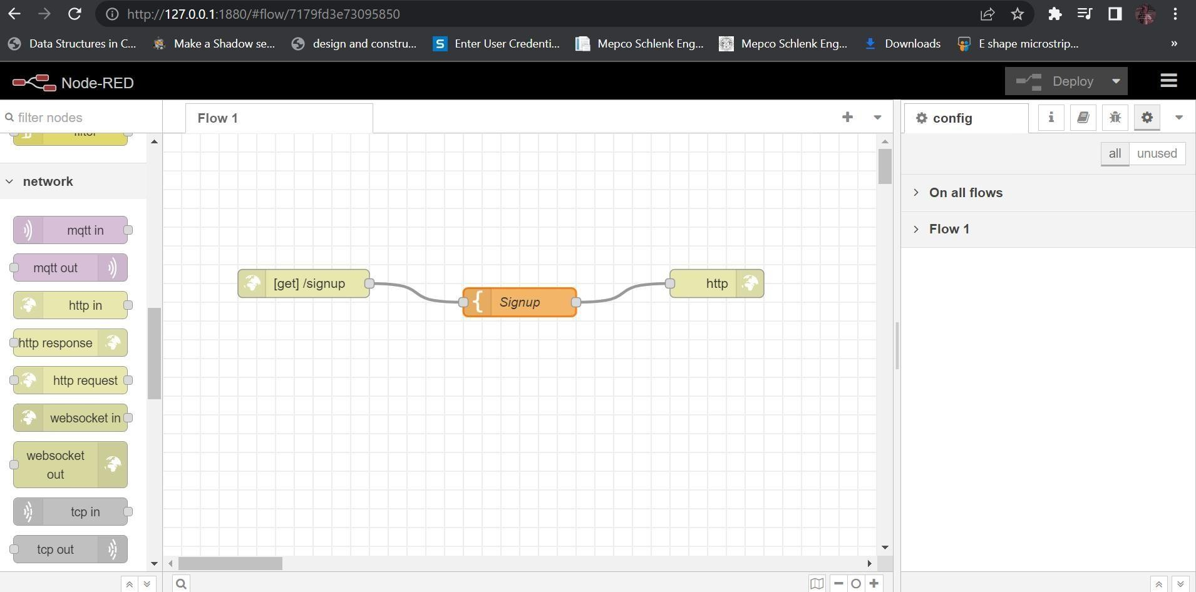

SIGN UP PAGE:

Link: http://127.0.0.1:1880/signup

